1. Dataset Class Balance (2 Points)
- Task: Create a bar chart showing the distribution of the primary labels/classes your model is predicting (e.g., token counts for English, Spanish, Code-Switch).
- Analysis Focus (0.5 Points):
  - Quantify the degree of class imbalance.
  - Explain why this imbalance necessitates the use of metrics beyond Accuracy (e.g., Precision, Recall, F1​-score).
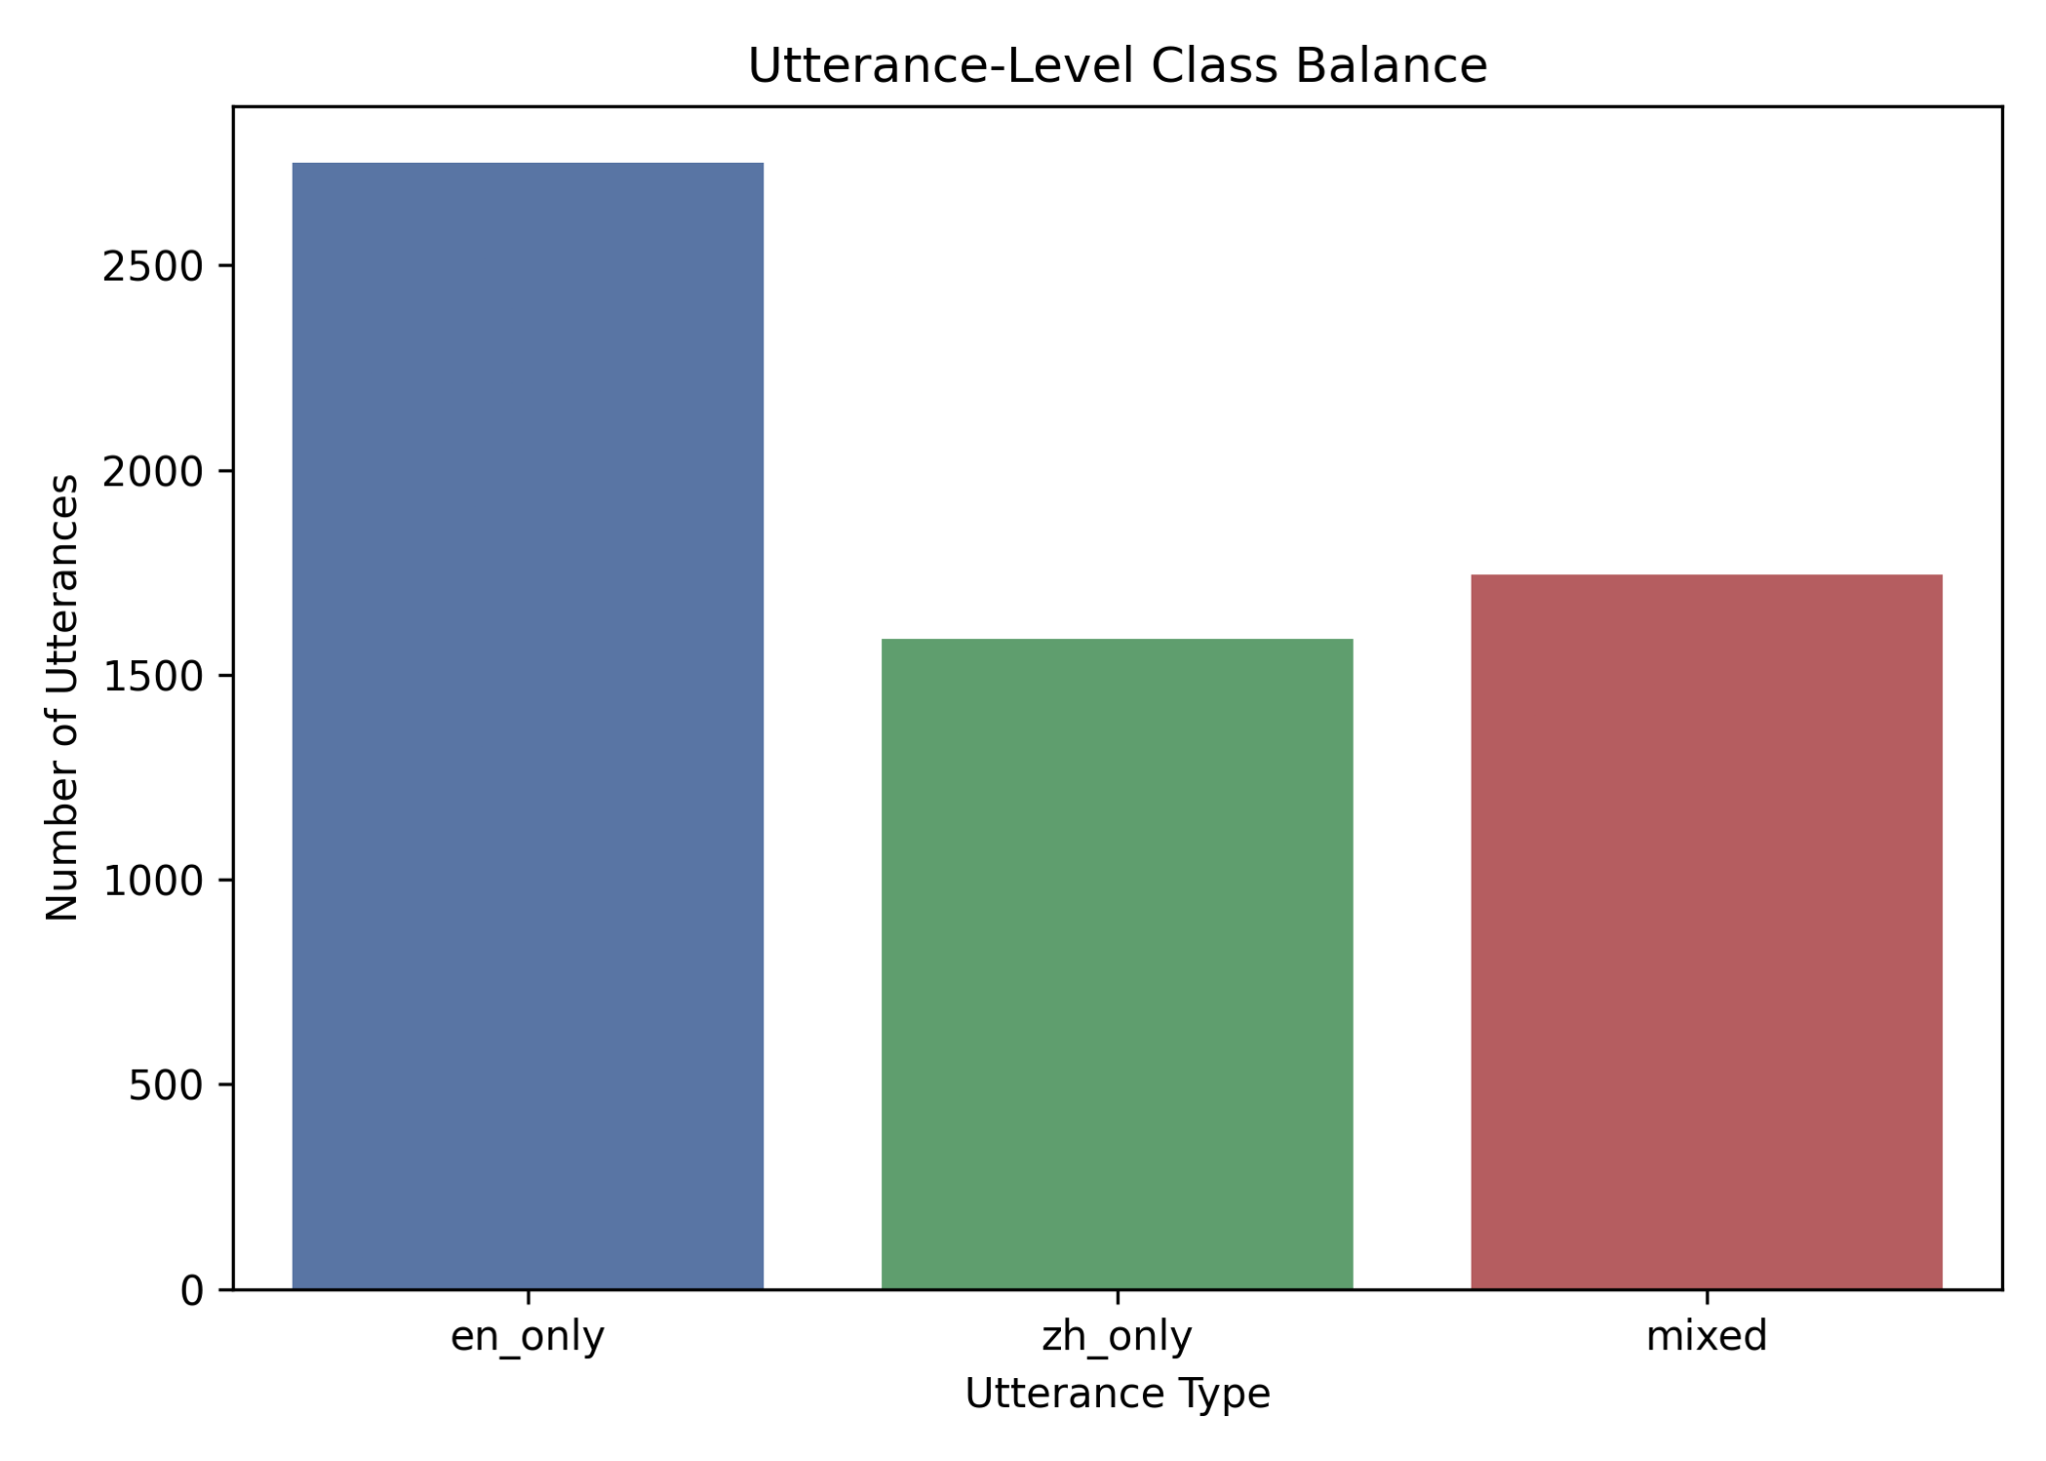
Most of the utterances in our dataset are in English, with over 2,500 instances, followed by mixed-language utterances at approximately 1,700 instances, and Mandarin-only utterances at around 1,500. This uneven distribution reflects realistic conversational patterns, since many speakers naturally complete their thoughts entirely in one language rather than switching mid-utterance. However, this class imbalance introduces significant challenges when evaluating model performance, particularly when relying on overall accuracy as the primary metric.
Because English dominates the dataset, a model can achieve a deceptively high accuracy by simply favoring the majority class. For example, in a hypothetical scenario where 80% of the dataset is English and the remaining 20% is evenly split between mixed and Mandarin, a model that predicts “English” for every utterance would achieve 80% accuracy without actually learning any meaningful linguistic distinctions. This creates a false impression of strong performance, even though the model completely fails to identify mixed or Mandarin-only utterances.
As a result, accuracy alone does not adequately capture the model’s true predictive capability. It overlooks how well the model performs on minority classes, which are often more important in tasks involving code-switching detection and language diversity. Metrics such as precision, recall, and F1-score (especially when evaluated per class) provide a more reliable and nuanced assessment, as they account for both false positives and false negatives across all categories. Therefore, any evaluation of the model must consider this imbalance to avoid overestimating its effectiveness and to ensure fair performance across all language types.

2. Code-Switching Frequency Distribution (2 Points)
- Task: Create a histogram showing the distribution of the Number of Code-Switched Tokens per Utterance/Sentence across the entire dataset. You may need to bin the counts (e.g., 0, 1-2, 3+ switches).
- Analysis Focus (0.5 Points):
  - Characterize the linguistic complexity of the generated data (Are switches rare, or is the data highly mixed?).
  - Predict the failure mode of your model: Based on this distribution, where will the model likely have the lowest Recall?
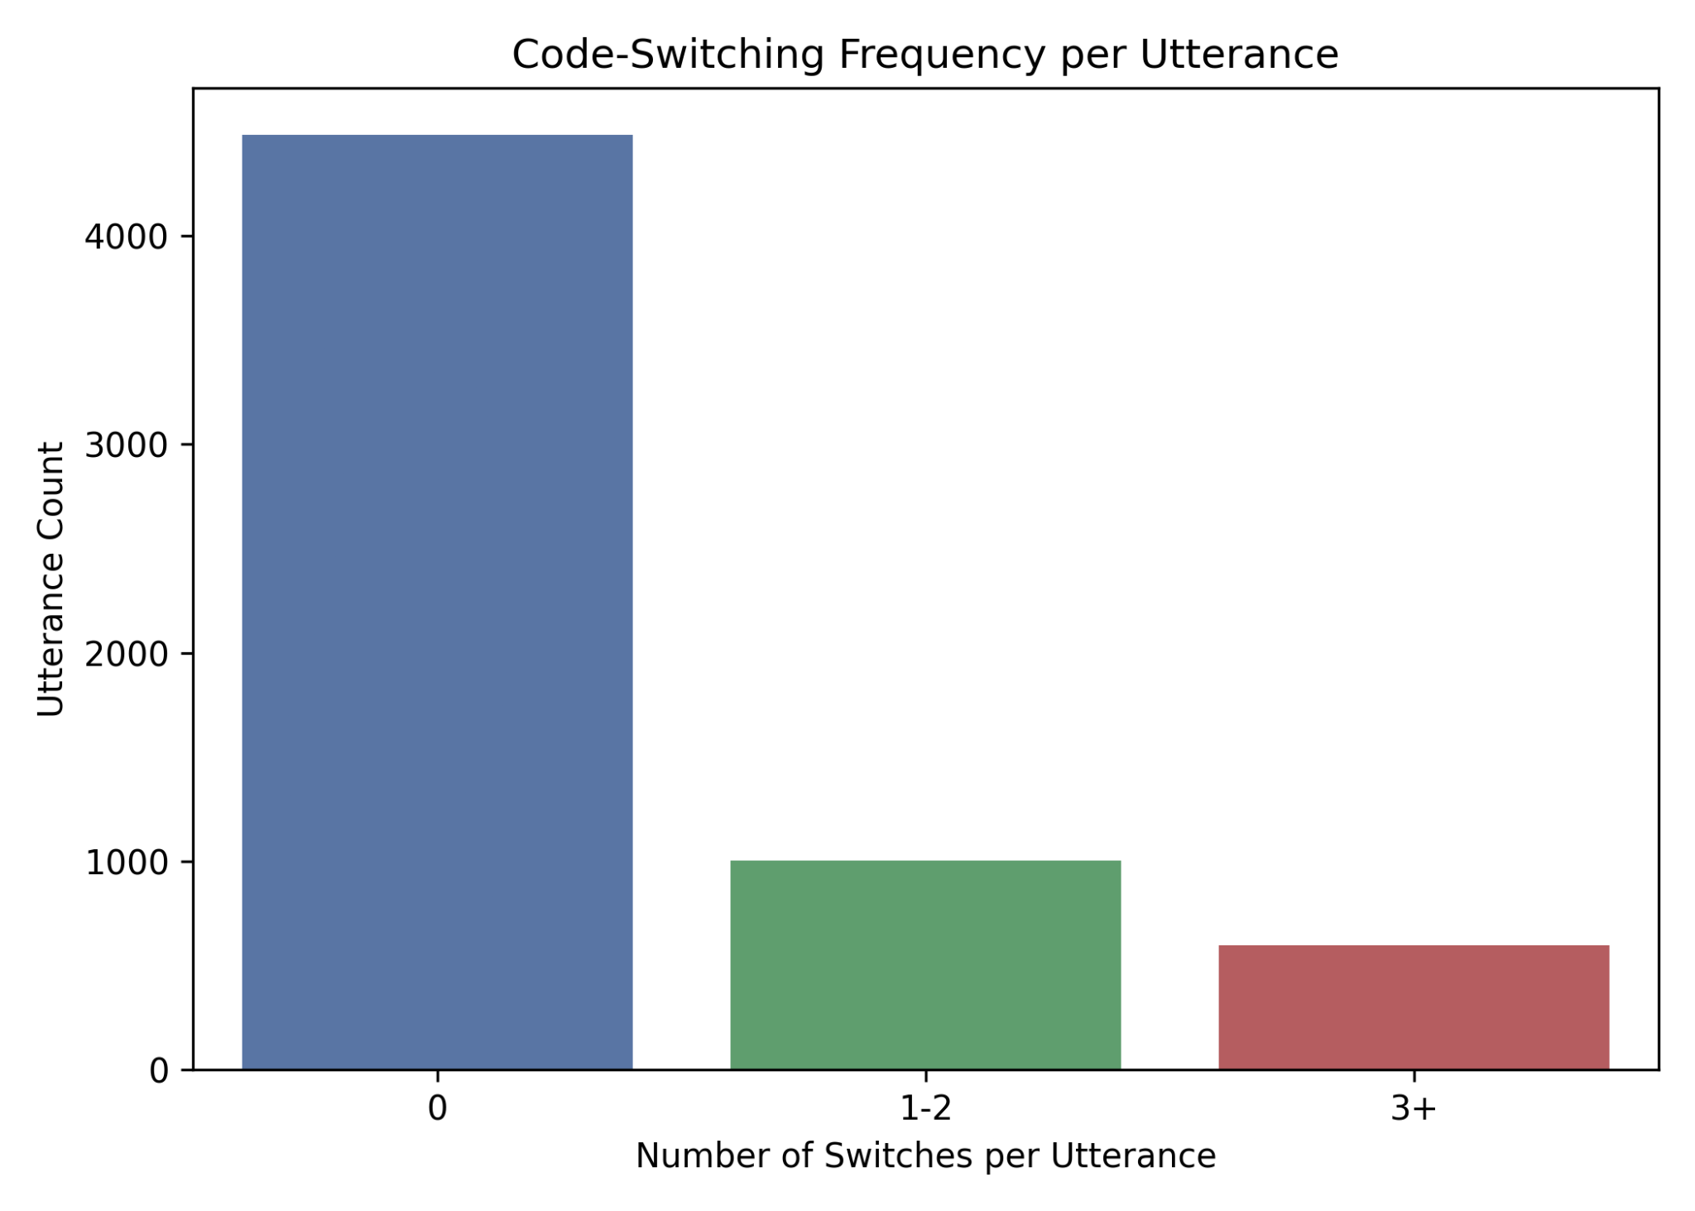
Since the number of switches in most utterances is typically zero, code-switching events are inherently sparse in the dataset. While there are approximately 1,000 utterances containing 1–2 switches, only around 700 contain 3 or more, indicating that complex switching patterns are relatively uncommon. This imbalance means the model is exposed far more often to non-switch or minimally switched examples, which negatively impacts its ability to learn and recognize rarer patterns.
As a result, the model is likely to exhibit lower recall for infrequent and structurally complex switch types, such as long-distance switches or those embedded within syntactically intricate sentences that require broader contextual understanding. In contrast, it will perform best on more common and predictable switch boundaries, particularly short, surface-level transitions that are easier to detect.
Additionally, the model may develop a tendency to overpredict switch occurrences. While this indicates that it is sensitive to potential switching cues, it also leads to false positives, where switches are predicted even when none are present. This imbalance highlights the need for more sophisticated approaches, such as sequence-based models (e.g., BiLSTMs or Transformers) that can better capture contextual dependencies, as well as targeted strategies like data augmentation or oversampling of switched utterances to improve exposure to rare and complex switching patterns.

3. Language Biases in Syntactic Features (2 Points)
- Task: Create a grouped bar chart comparing the frequency of at least three major Part-of-Speech (POS) tags(e.g., Noun, Verb, Adjective) within the dataset.
  - (Note: If full POS tagging isn't feasible, compare the frequency of the top 20 most frequent unigrams for each language.)
- Analysis Focus (0.5 Points):
  - Identify which language is syntactically more complex or dominant in the dataset.
  - Discuss how this imbalance in feature representation could lead to model bias against the less-represented language's grammar when predicting code-switching boundaries.
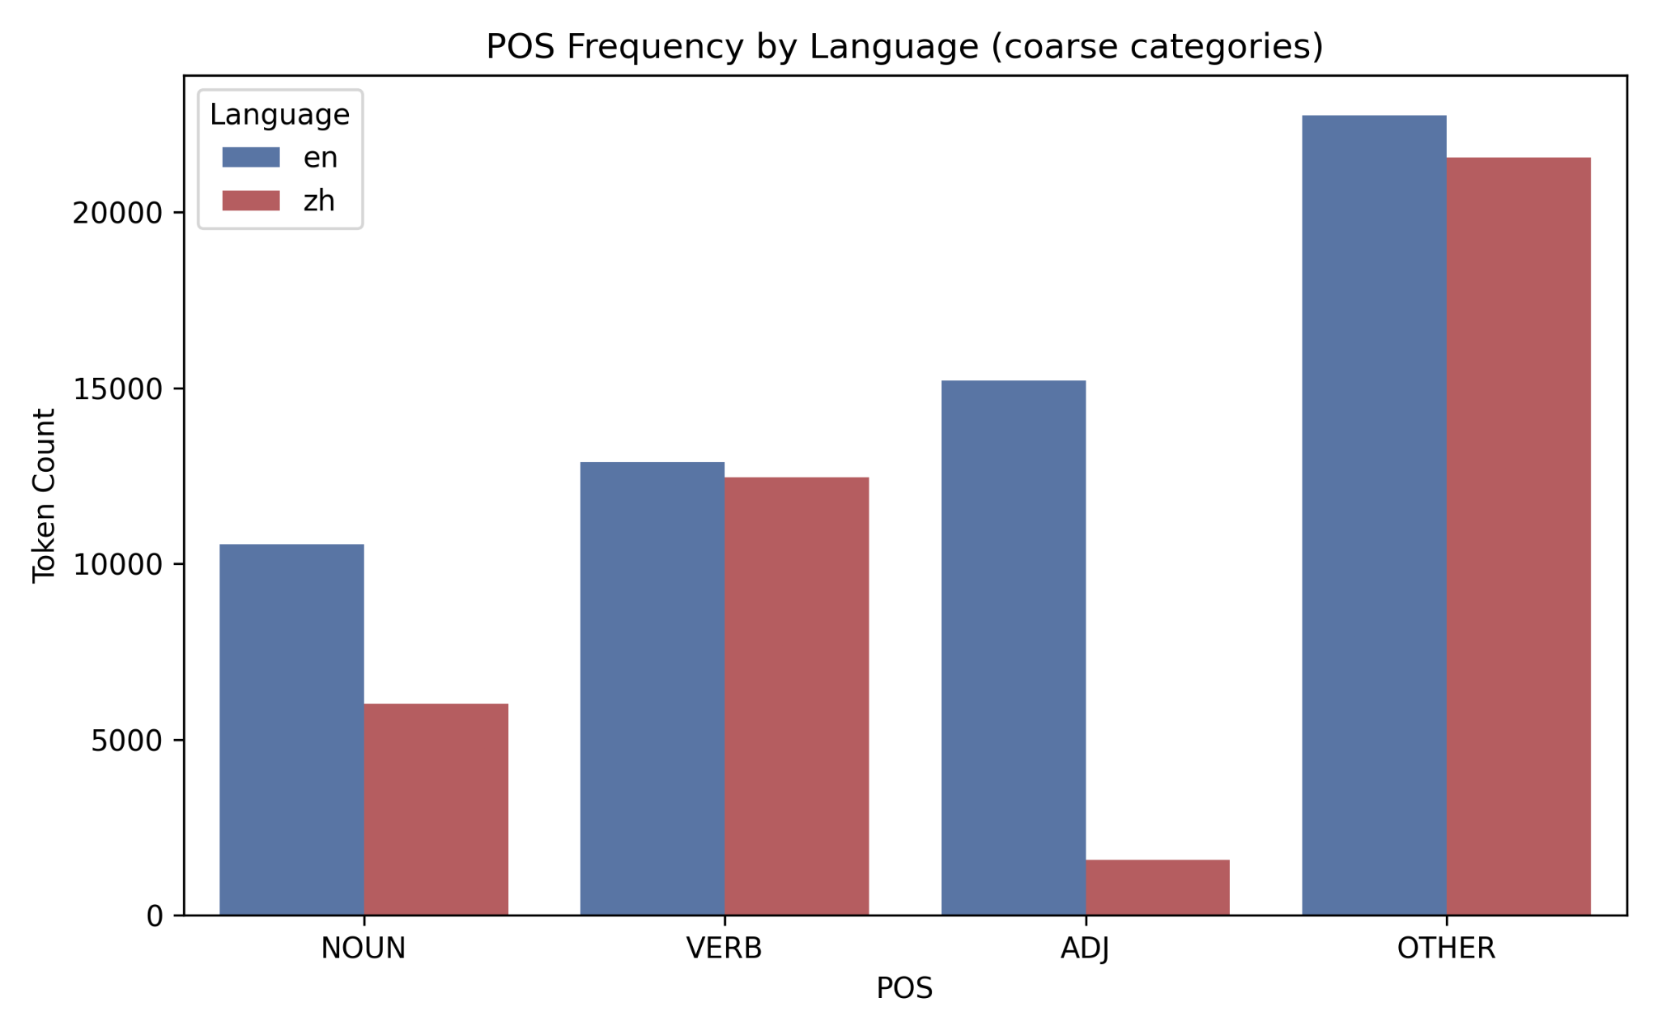
There is a clear class imbalance across parts of speech. English tokens dominate the adjective category, which is expected, as speakers often do not need to code-switch to convey descriptive meanings. In many cases, it is also more natural or efficient to express certain adjectives in English rather than in Mandarin. A similar pattern appears for nouns, particularly technical terms. Many engineers are unfamiliar with Mandarin equivalents for specialized vocabulary such as “PR” or “codebase,” and therefore default to English terminology when discussing technical concepts. On the other hand, verbs and the “other” category (primarily punctuation and function-related tokens) show a more balanced distribution between English and Mandarin. This likely reflects greater comfort among speakers in expressing actions and structural elements in their native language, even when technical nouns remain in English.
This imbalance introduces potential bias into the model if features are heavily influenced by POS distributions. For instance, the model may learn to depend on English-dominant syntactic patterns while failing to recognize Chinese-specific grammatical markers that often signal code-switch boundaries. As a result, performance may degrade in segments where Mandarin grammar plays a stronger structural role. To address this issue, we can integrate language-aware modeling strategies such as POS normalization across languages, bilingual word embeddings, and explicit language-conditioned features, enabling the model to learn switching cues more equitably from both linguistic systems.

4. Sentence Length vs. Code-Switching (2 Points)
- Task: Create a scatter plot or box plot to visualize the relationship between utterance length and code-switching frequency (CSI).
- Analysis Focus (0.5 Points):
  - State whether a correlation exists between length and code-switching frequency.
  - Critically assess if this correlation is a linguistic insight (based on real-world data) or an artifact of the LLM generation prompt/process. Explain the implication for model generalization.
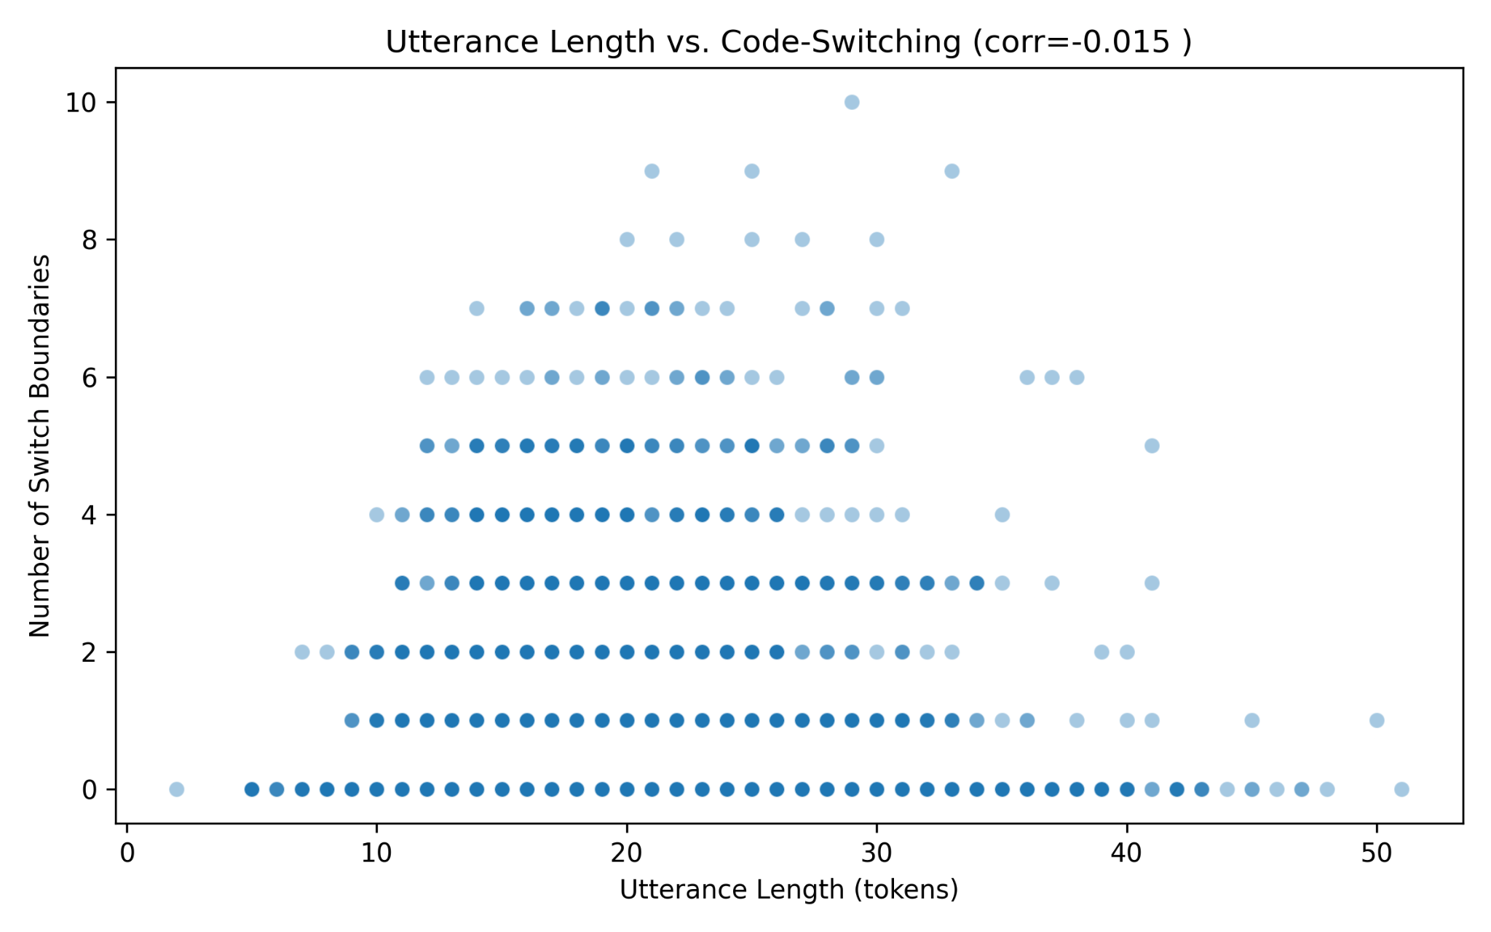
The visualization reveals no meaningful correlation between utterance length and code-switching frequency. Both short and long utterances have wide variability in the number of switching events, indicating that longer sentences do not necessarily contain more code-switches.
This suggests that code-switching is not a function of structural complexity or verbosity, but is instead driven by intent, topic change, lexical availability, or choice. Speakers may switch languages at highly specific points (like technical terms, emphasis, or discourse markers) regardless of how long the sentence is. The lack of correlation also indicates that the dataset does not suffer from artificial inflation of code-switching in longer sentences. If longer sentences had consistently higher CSI, it could suggest that the generation process introduced switches simply to increase linguistic complexity. The absence of this pattern implies that the switching behavior is more natural and contextually grounded rather than being tied to length.
From a modeling perspective, this means that the model cannot rely on sentence length as a heuristic for predicting switches. Instead, it must learn more fine-grained signals such as syntactic boundaries and lexical triggers. While this increases task difficulty, it also improves real-world generalization, since natural human code-switching does not follow simple rules like “longer sentence = more switches.” However, this also exposes a potential risk: if the model was implicitly assuming a length-based relationship during training, it may fail to generalize to real conversational settings. Therefore, feature engineering should prioritize contextual embeddings, sequential models (e.g., BiLSTM or Transformers), and token-level context rather than surface-level attributes like utterance length.

